Economics ASSIGNMENT
Student’s Name
Course Title
Institution Affiliation

Question 1
- Price elasticity-low income patients-(-0.3)
Other income patients-(-0.05)
100%+10%=110%
110/100*(-0.3)
1.1*(-0.3)
=-0.33%
Low income patients=-0.33%
110/100*(-0.05)
1.1*(-0.05)
=-0.055%
Other income patients=-0.055%
Impact:
The degree of income elasticity varies in accordance with the nature of commodities
consumers consume in general. Where the commodity is a basic necessity, the
demand is not very responsive to change in income. Thus in this scenario, the impact will yield the elasticity to being negative (less than zero).
- Original price (low income patients)=$10
Original price (high income patients)=$30
100,000*10=1,000,000
110/100*10=11
100,000*11=1,100,000
200,000*30=6.000,000
200,000*33=6,600,000
Impact:
It can thus be said that when a commodity has inelastic demand it pays the government to
tax that commodity heavily because the greatest part of the tax is met by consumers, thus leaving the production of that good more or less unaffected, hence enabling the government to collect more revenue from that good. There will be an increase in revenue of the pharmaceutical product in low-income patients from $1,000,000 to $1,100,000 and also in high income patients by $600,000 from $6,000,000 to $6,600,000.

Question 2
- The features of flu vaccine that impose it to externalities are: flu is a highly contagious disease which can largely affect a huge number of people if not properly handled therefore needing government intervention and regulation. Besides, the vaccination could contain side effects to consumers thus posing a negative externality to consumers. Furthermore, market forces and need for the vaccination might need regulation so as to cause market failures in the aspect of overcharging customers.
- (i) The government regulation in the flu vaccination to achieve efficiency posses positive externalities. In the market scenario with several consumers, the individual demands are culminated together to give the marginal private benefits since it measures and evaluats the benefits received by the consumers who purchased the flu vaccine in particular. Besides, market consumption provides incentives for discovering new technology this enticing firms generate higher returns to scales.
(ii) Due to the flu vaccine, there is creation of production externalities. For instance, pollution and depletion of natural resources, the production firm might generate unwanted costs of replacements and replenishments.

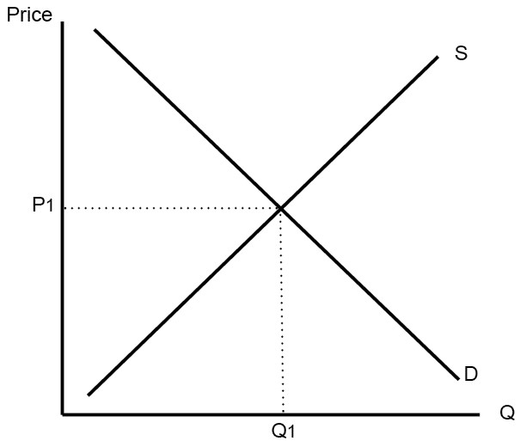
Whenever there is no government intervention, imposition of an externality causes production and the consumption level of the vaccination to cause third parties to incur unplanned expenditures. Besides, the equilibrium that is meant to bring the real balance between the buyers benefits and production costs cause market failures.
Question 3
Qty produced | Fixed cost | Variable cost | Total cost | Average total cost | Average variable cost | Marginal cost | Marginal revenue | Total revenue | Profit
0 | 25 | 0 | 25 | 0 | 0 | 0 | 0 | 0 | -25
1 | 25 | 35 | 60 | 60 | 35 | 25 | 25 | 40 | -20
2 | 25 | 60 | 85 | 42.5 | 30 | 12.5 | 25 | 80 | -5
3 | 25 | 80 | 105 | 35 | 26.7 | 8.3 | 24.9 | 120 | 15
4 | 25 | 95 | 120 | 30 | 23.8 | 6.2 | 24.8 | 160 | 40
5 | 25 | 105 | 130 | 50 | 21 | 29 | 45 | 200 | 70
6 | 25 | 125 | 150 | 25 | 20.8 | 4.2 | 25.2 | 240 | 90
7 | 25 | 155 | 180 | 25.7 | 22.1 | 3.6 | 25.2 | 280 | 100
8 | 25 | 186 | 211 | 26.4 | 23.2 | 3.2 | 25.6 | 320 | 109
9 | 25 | 225 | 250 | 27.8 | 25 | 2.8 | 32.4 | 360 | 110
10 | 25 | 280 | 305 | 30.5 | 28 | 2.5 | 25 | 400 | 95

(b) The marginal costs above depict the above pattern due to the essence of decreasing returns to scale. The marginal cost reduces with time with the introduction of new producer inputs and will increase only with the rise in consumption level.
Question 4
Qd=500-5p
Qs=50+10p
- Equilibrium price
500-5p=50+10p
500-50=10p-5p
450=15p
P=30
Equilibrium price=30

Equilibrium quantity
500-5(30)
500-150
=350
Equilibrium quantity=350

iii) The equilibrium point is the efficient point of consumption and production because it is the point where the quantity demanded equals quantity supplied.
Question 5
- Supplier induced demand is a market situation whereby there is no uniformity or homogeneity of information between consumers and producers (suppliers) and hence the producer can decide to use the superior information they enjoy to encourage consumers to demand for a service or good that they supply higher than the equilibrium level eventually leading to a welfare loss scenario.

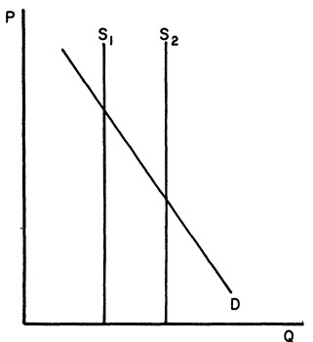

- 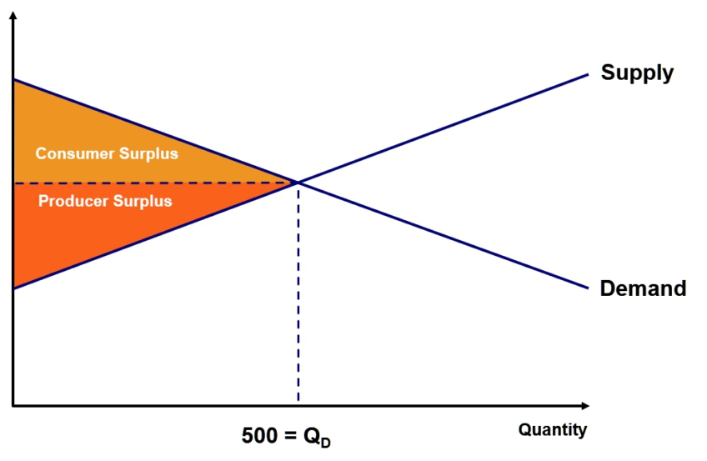
The deadweight losses are the shaded areas showing both the consumer surplus and producer surplus.

